**find Assignment**

1. **Search and display all *.c and *.h files in all subdirectories starting from current directory**

**Ans** : Now my current directory is bhimafldr and in that sub directories are day06 /

cTagsTools/ ctags/ project /mod1/ include from this the file with .h extension are display by using the command **find ./ -name “*.h”** similarly by using the command

**find ./ -name “*.c”** the files with .c extension are displayed in all subdirectories starting

from current directory and also the files with .c extension and .h extension can be found

through a single command.

**find . -name “*.c” -o -name “*.h”**

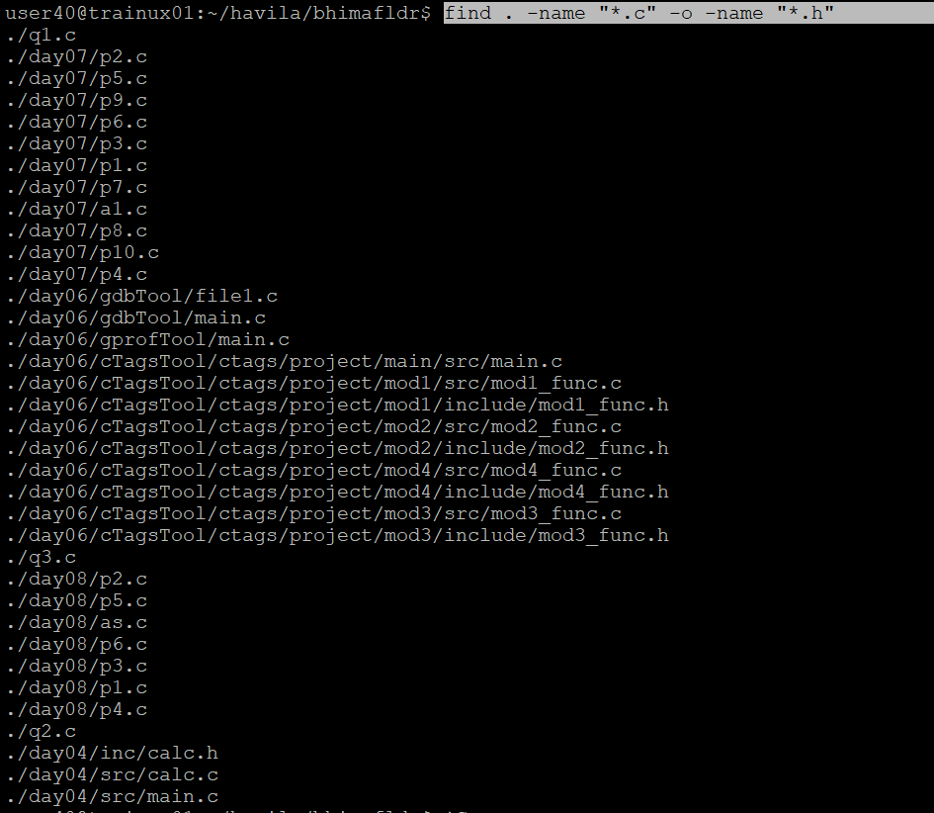

**2. Search and display all directories in all subdirectories starting from current directory**

**Ans:**

**find . -type d** is the command used to search and display all directories in all subdirectories starting from current directory

**.** 🡪 start search from the current directory.

**-**type d 🡪 only matches directories so it excludes files

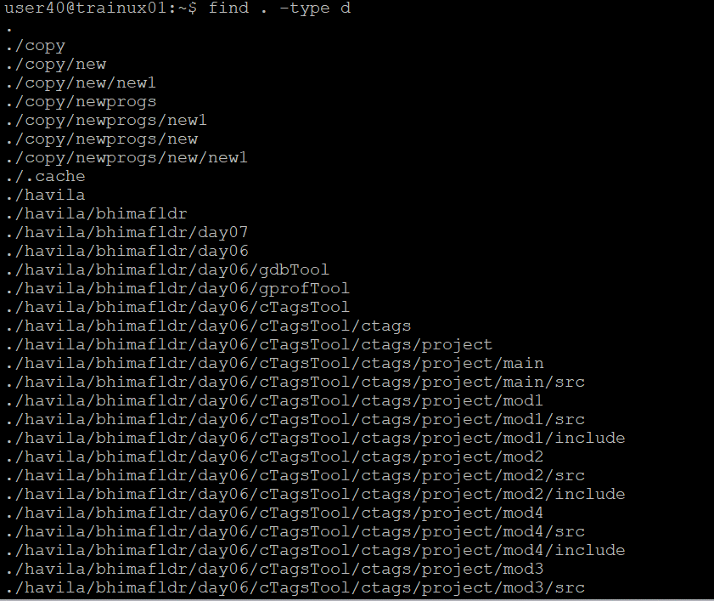

**3.Search and display all files with permissions only rw with user and execute permission for others**

**Ans:**  To search and display all files with permissions only read and write with user and execute permission for others the command used is

**find . -type f -perm u=rw,o=x**

here there is only one file **file2.txt** withthe permissionsallowing only users to student right and others to execute

